Design BE eID test environment

1. Introduction

This is a project for FedICT, meant to make it easier to test applications for the BE eID card. Currently, the problem is that lots of cards would be needed to test all possible cases (languages, max/min sizes of the fields, strange characters, cert status, …)

The solution we provide will make it possible for a developer/tester to use ‘virtual cards’, optionally in ‘virtual readers’. These virtual cards can be download from a website.

The figure below displays the general architecture overview of our solution,
consisting of the following main components:
- On the server side: a web server, database and OCSP responder
- A client side PCSC proxy library: virtual card and reader emulation
- A client side control library/application: control of the virtual cards and readers
- A client side PIN unblock application
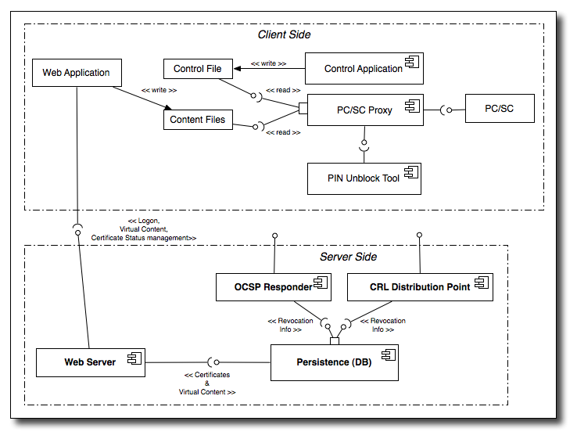
Each component will be explained the sections below.

2. The server side

Remark: most things on the server side will be done by our partner Arena Solutions. We only have to provide:
- a library that generates the virtual cards
- the OCSP reponder (who gets it data from the Database)
- a program that generates the CRL (who also gets its data from the Database)

2.1 Database

The Database will contain the following data:
- The contents of the real and virtual cards
- For each certificate: the status (suspended, revoked, ..). This is needed for the CRL and OCSP generation.

2.2 Web server

The web server will contain the following static and dynamic pages:
- a main page with general information and the posiblity to login in with the developer eID card for access to the other pages
- optionally a 'documents' section with relevant documentation
- a page to create the contents of a new virtual eID card
- a page to change the status of the certificates
- a page where the generated CRLs can be downloaded
- the CRLs and delta CRLs

2.2.1 Creating contents for new virtual eID cards

The developer will see a form containing all the ID and address values that can be specified, as well as validity period of the certificates and their initial status. Depending on the profile chosen (EID, kids, foreigner, ...) certain fields in the form will be hidden while the other fields have default values for that profile.
After modifying certain fields (optionally), the developer can click a 'Create virtual card' button upon which a file containing the virtual card's contents will be downloaded on the developer's hard disk. This file will then be used by the client side components to emulate a
virtual card.
When clicking the 'Create virtual card' button, the web server will check the inputs and then generate the eID card contents, using a unique card serial number and the public keys of the real developer card. (The authentication public key is directly derived from the certificate that was used to log in to the web server, the signature certificate is looked up in the Database, taking the authentication certificate as a key.)

2.2.3 Changing the status of the certificates

The developer will see the list of the Authentication and Signature certificates of his/her developer card plus those of all virtual cards he/she created. For each certificate, the current status and a drop-down box containing the possible new status-es is shown.
Only valid state transitions are allowed in order not to confuse applications with invalid (delta) CRLs. As a result, the status of a revoked certificate can't be changed anymore. However, since the developer can create new certificates on new virtual cards this is
no big limitation.
The changes make are immediately propagated to the OCSP responder and will appear in the next CRL.

Overview of the valid status changes :
Nummer | Current status | New status
1 | Suspended | Active
2 | Suspended | Revoked
3 | Active | Suspended
4 | Active | Revoked

2.3 CRL generation

Each our a CRL, and each 15 minutes, a delta CRL is generated (so for each main CRL 3 delta CRLs) by means of a separate thread in the webserver, by means of the info in the Database.

2.4 OCSP responder

This server will respond to OCSP requests, taking as input the status
of the certificates as set by the developer.
Care will be taken to mimic the behaviour of the real OCSP responder
as close as possible.

2.5 PKI
From the above it follows that we have chosen not to use a separate PKI but instead integrete the different components (cert/CRL generation, OCSP) in our webserver. Because we are only dealing with test cards and only 2 types to be made dynamically (the citizen’s Authentication and Signature certificate), a full CA would give an unnecessary additional complexity.
All certs correspond with the current official certs, except for the CRL, OCSP, CPS and CA issuer URLs, the Distinguished Names and public keys. The full hierachy for the old and new root CA is being mimiced (self-signed and root-signed CA certs, internmediate CA, RRN, OCSP and user certs). Considering it’s just a test PKI, the corresponding keys (except other of the user certs) are generated in software and the private key of the internmeidate CA, RRN and OCSP responder are present on the server without any special protection (such as an HSM). The CPS is a short document that clearly states it’s just a test PKI that shouldn’t be used for any other goals.

2.6 Technology used

The OCSP responder will be based on the free Novosec OCSP responder servlet, using the Bouncycastle OCSP classes to parse/generate OCSP requests/responses. Bouncycastle will also be used for the CRL generation. Generation of the certificates is based on existing code at Zetes and uses the IAIK library.

3. The client side

On the developer's PC, a PCSC proxy library allows the developer to use virtual cards and even virtual card readers. Which virtual cards are present in which (virtual) readers is can be controlled by the developer by means of a control library or control application.
The communication between this control library/application and the PCSC proxy library goes via control files on the hard disk.

3.1 The PCSC proxy library

The PCSC proxy library will have the same interface as the real PCSC library that is provided by the Operating System (e.g. winscard.dll on Windows). Developers/testers will use this library instead of the real PCSC library.
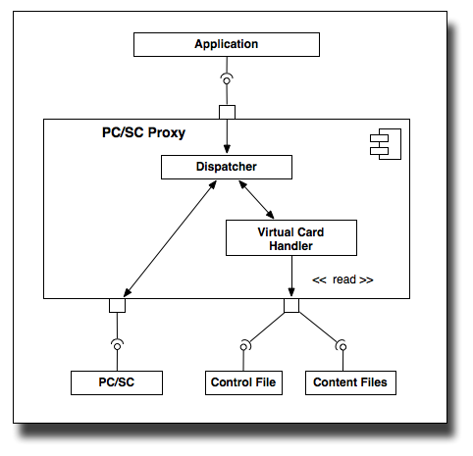
The PCSC proxy library will do the following:
- forward calls for the real readers/cards to the real PCSC library
- implement the functionality for virtual cards and virtual readers

For each real card reader, a virtual card reader will be emulated by the PCSC proxy lib. In this virtual reader, a virtual card will be present if a real card is present in the real reader. (So removing the real card means also removing the virtual card; and removing the real reader means removing the virtual reader). Which card is linked to a real card, is precified in a control file that can be manipulated by a control library (see below).
Optionally, the real reader/card could be hidden.

Implementation details for the card emulation:
- Since PIN verification/change and crypto operations are dispatched to the real card, only the following card commands have to be implemented:
  - Get Card Data
  - Select
  - Read Binary

Technology used: since the PCSC API is a C API and since the PCSC proxy
library will call the real PCSC library, C/C++ will be used here.

3.2 Control library

A library will be made providing the following functionality:
- Specify which virtual card is present in which virtual reader
- Specify wether or not the virtual reader is listed before or after the real reader, and whether or not the real reader is visible.

Communication between the control library and the PCSC proxy library is done via control files: changes to these control files are made by the control library and are read by the PCSC proxy library.
By using files, no complicated, platform-dependent ways of communication is required.

Additionally, a command line application on top of the command library will be implemented, allowing easy integration into scripts.

Control schema file:

<?xml version="1.0" encoding="UTF-8"?>
<xs:schema xmlns:xs="http://www.w3.org/2001/XMLSchema">
<xs:element name="control">
<xs:complexType>
<xs:sequence>
<xs:element name="show">
<xs:simpleType>
<xs:restriction base="xs:string">
<xs:enumeration value="REAL_FIRST" />
<xs:enumeration value="REAL_LAST" />
<xs:enumeration value="HIDE_REAL" />
<xs:enumeration value="HIDE_VIRTUAL" />
</xs:restriction>
</xs:simpleType>
</xs:element>
<xs:element name="virtualcard" minOccurs="0" maxOccurs="unbounded">
<xs:complexType>
<xs:sequence>
<xs:element name="hardchipnr" type="xs:string" />
<xs:element name="file" type="xs:string" />
</xs:sequence>
</xs:complexType>
</xs:element>
</xs:sequence>
</xs:complexType>
</xs:element>
</xs:schema>

Many of the documents we use including this one make use of XML as it is a convenient mark-up language. However the problem with Xml is that it can be awkward to work with in that the complexity required of the parser can sometimes be high. Consequently many developments resort to using an off-the-shelf library for this purpose. Our XML implementation requires only basic XML functionality and therefore as such it was not considered worth the overhead of an external library so a basic Xml parser class is developed. The two classes that require XML functionality (ControlFile & VirtualCard) are derived from the Xml class.

The following class is implemented to handle control files. It is derived from Xml.

class ControlFile: public Xml
{
.
.
public:
// given a hard chip id # return a string vector containing all paths to
// virtual cards that correspond to this hard id
std:: vector<string> ControlFile::GetVirtualFilePaths(char *hardchipnr);
.
.
};

3.3 Control application

The control application allows the user to make changes to the control file. The application supports a command line mode as well as a graphical mode.

Command line arguments:

Usage: pcsccontrol <options>
pcsccontrol [no options starts graphical mode]

Options:
Set control file path : -setControlFile <path>
Show control file path : -showControlFile
Set visibility : -setVisb <mode>
(mode is one of: [HIDE_REAL, HIDE_VIRTUAL, REAL_FIRST, REAL_LAST])
Show visibility : -showVisb
List available virtual card dirs : -listDirs
Add virtual card dir : -addDir <path>
Delete virtual card dir : -delDir <path>
List available virtual cards : -listCards <physical chipnr>
List available physical chip nrs : -listChipnrs
Set virtual card path : -setCard <physical chipnr> <path>
Show active virtual card : -showCard <physical chipnr>
Verbose (only text mode) : -verbose
Show version and exit : -version
Show this help : -h

Screen shot:

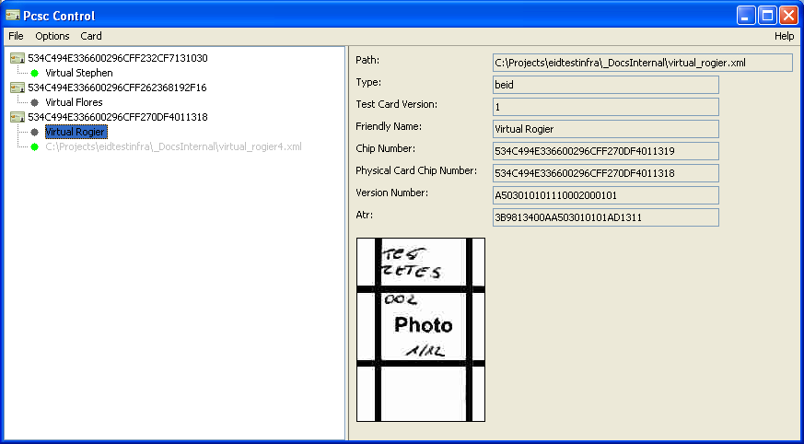
Class diagram:

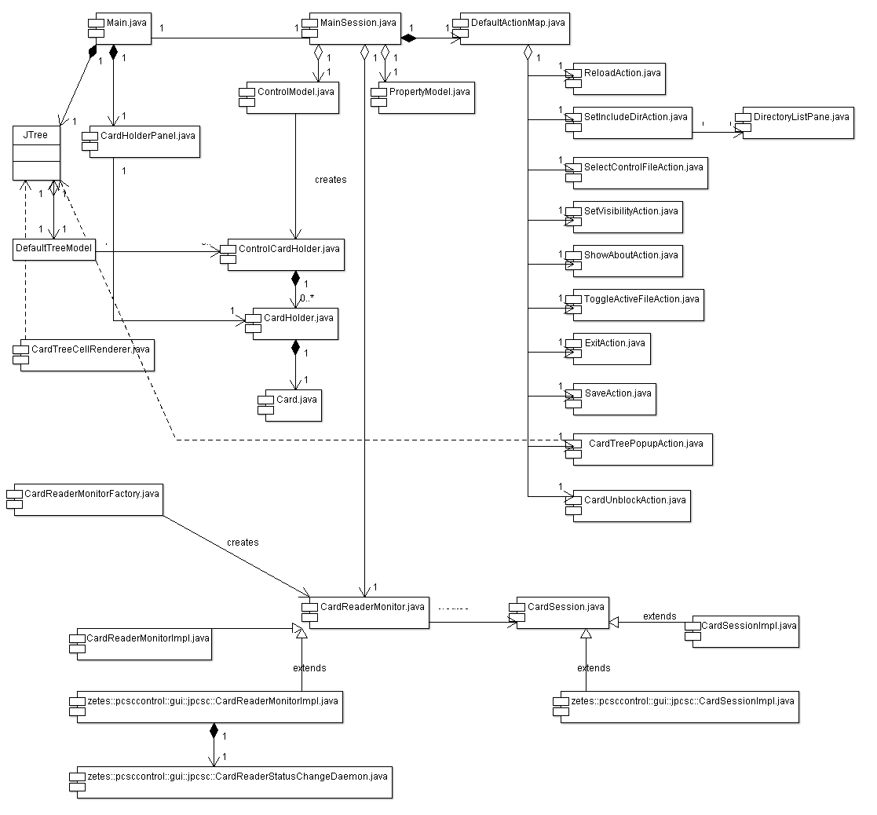

3.4 Pin unblock application

Technology used: Java and a JNI PCSC wrapper; perhaps combined with the control application into 1 single application.

Class diagram:
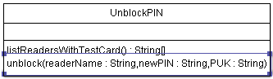
The listReadersWithTestCard() method returns the list of all readers in which a test card is present. The unblock() method unblocks the card in the specified reader.

Since this Java library must access PCSC for this, a JNI stub is needed for this. A good candidated would be the jpcsc library:
http://www.musclecard.com/middleware/files/jpcsc-0.8.0-src.zip

Here are the command to verify the PUK and to do the PIN reset:

IN: 00 20 00 02 08 2C 33 33 33 11 11 11 FF (Verify PUK = 333333111111)
OUT: 90 00

IN: 00 24 01 01 08 24 12 34 FF FF FF FF FF (Reset, new PIN = 1234)
OUT: 90 00

Remark1: if the first command returns SW12 = 63 Cx or 69 83, then the PUK is wrong and this should be clearly stated in an Exception.

Remark2: the PUK is always 12 bytes, so the ‘format byte’ is always 0x2C.
For t he PIN, the length can be between 4 and 12 bytes, so the ‘format byte’ can vary between 0x24 and 0x2C.
E.g. is PIN = “12345” ->

Note: probably the PUK will be a fixed value, which would imply that the unblock(readerName : String,newPIN : String,PUK : String) would be made private and a new public method unblock(readerName : String,newPIN) would be added.

4. File formats

4.1 Virtual card file format
Virtual cards contents are generated at the server and downloaded in 1 file per card to the clients’ PC. On the client PC, this file is used by the pcsc proxy library and the control library.

Virtual card schema file:

<?xml version="1.0" encoding="UTF-8"?>
<xs:schema xmlns:xs="http://www.w3.org/2001/XMLSchema">
<xs:element name="card">
<xs:complexType>
<xs:sequence>
<xs:element name="type" type="xs:string" />
<xs:element name="testCardVersion" type="xs:string" />
<xs:element name="friendlyName" type="xs:string" />
<xs:element name="chipNumber" type="xs:string" />
<xs:element name="physicalCardChipNumber" type="xs:string" />
<xs:element name="versionNumber" type="xs:string" />
<xs:element name="atr" type="xs:string" />
<xs:element name="file" maxOccurs="unbounded">
<xs:complexType>
<xs:sequence>
<xs:element name="id" type="xs:string" />
<xs:element name="content" type="xs:string" />
</xs:sequence>
</xs:complexType>
</xs:element>
</xs:sequence>
</xs:complexType>
</xs:element>
</xs:schema>

The VirtualCard class handles virtual cards. VirtualCard is derived from Xml class.
class VirtualCard : public Xml
{
public:
.
.

std::vector<string> GetAllData(char *path);
char *GetType(){return m_type;}
char *GetTestCardVersion(){return m_testCardVersion;}
char *GetFriendlyName(){return m_friendlyName;}
char *GetChipnr(){return m_chipNr;}
char *GetDevCardChipNr(){return m_devCardChipNr;}
char *GetVersionnumbers(){return m_versionNumbers;}
char *GetAtr(){return m_atr;}
void VirtualCard::GetData(char *id,char * result);
.
.

};

Smart Card Proxy DLL Architecture

Application
Scard DLL
Scard Driver
Scard Hardware
Application
Scard DLL
Scard Driver
Scard Hardware
Scard Proxy DLL

Virtualization is realized on the level between the User Application and the Driver level. The existing dll (wincard.dll on windows and libpcsclite.so on Linux) is accessed through a new to be created dll that acts as a proxy for the existing dll.

Exactly one soft card reader will be present for every hard card reader attached to the pc. When
a hard card gets inserted in the reader, a soft card gets inserted in the soft reader. When a hard card gets removed from the reader, the associated soft card gets removed from the soft reader.

More than one soft card may belong to one hard card. The mapping between soft cards and hard cards is stored in a control file on disk. A hard card is identified by its chip number. The chip number is used to associate soft cards with hard cards. Although more soft cards may belong to one hard card, only one soft card can be the active one. The active soft card is the one that gets inserted into the soft reader when the hard card gets inserted into the hard reader. The control file indicates the currently active soft card for a hard card.

A to be created GUI is used to maintain the information inside the control file. This application provides the following functionality to the user:
- Specify the disk locations of files that contain the contents of the soft cards.
- Specify the active soft card for a hard card.


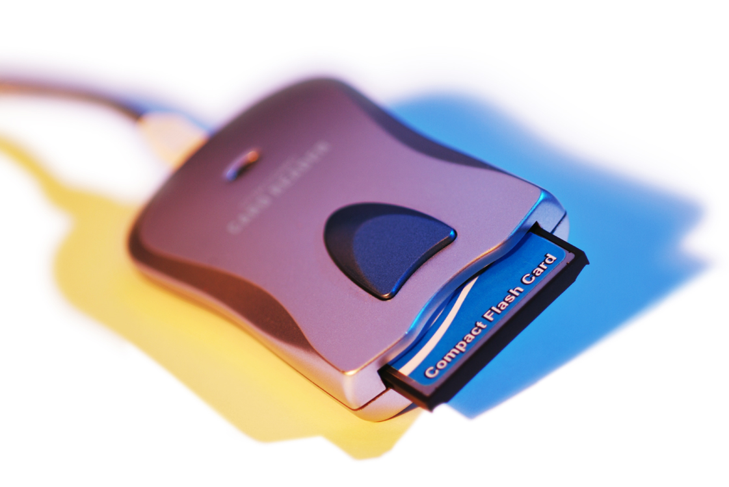
Hard Reader 1
Hard Reader 2

Be-id
Soft Reader 1
Soft Reader 2
soft
Be-id
soft
Be-id
soft
Be-id
soft
Be-id

Be-id
Control file
Proxy DLL
Lookup active soft card
Set active soft card
beid

Proxy DLL Use Cases
The following use cases are explicitly implemented by the proxy dll. That means that specific code has been implemented to handle the request which does more than simply forward the request to the original dll.

Winscard Proxy

SCardListReaders
SCardConnect
SCardBegin-Transaction
SCardEnd-Transaction

SCardControl
SCardTransmit
SCardDisconnect
SCardResconnect
SCardFree-Memory

Application
SCardStatus

SCardGetStatus-Change

Proxy DLL Classes

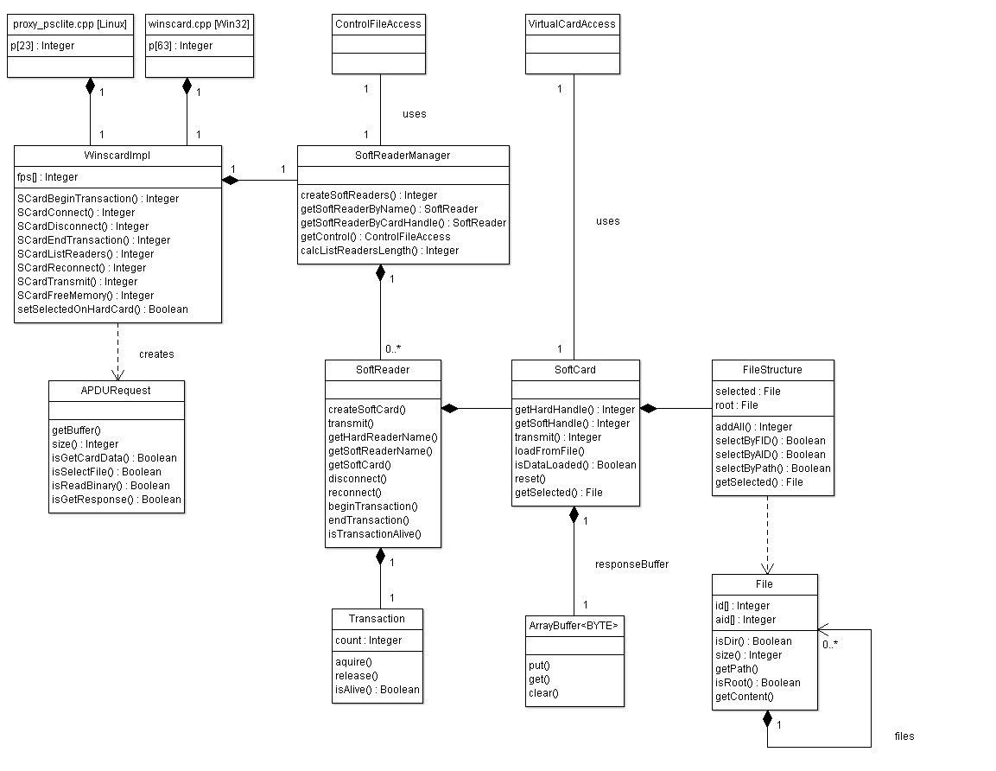

SCardListReaders
More than one card reader device can be attached to one PC at a time. The application discovers the available readers by calling SCardListReaders on the dll. All commands pass through the proxy. The proxy sends the SCardListReaders command to the original dll. When the proxy receives the response it will create one soft reader for each hard reader attached. The soft reader receives a name which is the name of the hard reader with a prefix.
Example:
- Name of hard reader: “Gemplus USB Smart Card Reader 0”
- Name of soft reader: “!Virtual Gemplus USB Smart Card Reader 0"

The names of soft readers are added to the string containing names of hard readers and the full string is passed in the response to the application.

[mszReaders + virtualsoft]
App
Proxy DLL
Real Original DLL
SCardListReaders
SCardListReaders
[mszReaders]
Real DLLSoft Reader
[mszReaders]foreach hard reader
Real Soft Reader Manager DLL
SCardListReaderscreateSoftReaders(mszReaders)
Real DLLControl
SCardListReadersnew
SCardListReadersgetListReaderOrder
SCardListReaderssort
[mszReaders + virtualsoft]

new

SCardConnect
The application sends the SCardConnect operation to receive a handle to the card. If the SCardConnect contains a hard reader name then a handle to the hard reader is returned to the client. If the SCardConnect contains a soft reader name then a handle to the soft reader is returned to the client. The proxy stores the soft handle with the hard handle, so that in any future operation in which a soft handle is passed, the corresponding hard handle can be looked up and used to access the hard card if required.

App
Soft Card
Proxy DLL
Original DLL
map hard handle
with soft handle
Soft Reader
Soft Reader Manager
SCardConnect(name)
check if SoftReader is NULL

[LPSCARDHANDLE]
getSoftReaderBySoftName
hard handle
new

insert scard

[soft LPSCARDHANDLE]
SCardConnect(name)
Look for a soft reader with the supplied name. If there is no soft reader, the name must belong to a hard reader, see Option A.
[A]: Name is of hard reader:
Just pass the request to the original dll and return the hard handle to the app. Don’t do anything with soft readers.
A
getHardName
B
SCardConnect(hard name)
createSoftCard(hard handle)
new
getSoftHandle
soft handle
[B]: Name is of soft reader:
Get the hard name from the soft reader and connect to the hard card to fetch the hard handle. Create a soft card and return its handle to the app.

SCardBeginTransaction/SCardEndTransaction
An application is able to interact with the card by starting a transaction, sending commands and ending the transaction. There is no commit and rollback mechanism. The transaction only serves to block other applications from accessing the card simultaneously.

For both SCardBeginTransaction() and SCardEndTransaction() the following is true when the reader handle is a:
- hard handle: the proxy forwards the request to the original dll only.
- soft handle: the proxy forwards the request to the hard reader as well as to the soft reader.

App
Proxy DLL
Real Original DLL
SCardBeginTransaction(virtualsoft)
SCardBeginTransaction(physicalhard)

Virtual Soft TransactioReadern
Lookup physical hard handle by virtualsoft handle

newbeginTransaction

SCardEndTransaction(virtualsoft)
SCardEndTransaction(physicalhard)

deleteendTransaction

success
/// do things within transaction ///
success
Virtual TransactionTransaction
newaquire

newrelease

release mutex

aquire mutex

The proxy dll lives in the memory space of the application. In order to shield of transactions on the soft reader the Transaction class contains named mutex is used.

SCardControl
success
SCardControl functions such as those that interact with the pin pad are only forwarded to the hard reader even if a handle to a soft reader is passed.

App
Proxy DLL
Original DLL
SCardControl(hard)
SCardControl(hard)

App
Proxy DLL
Original DLL
SCardControl(soft)
Lookup physical hard handle by virtualsoft handle
SCardControl(hard)

SCardTransmit
An SCardTransmit call is used to send APDU’s to the card. Before the SCardTransmit,
the application send a SCardConnect. At the time of connect the chip number of the physical card was unknown and because the chip number serves as the key to lookup the virtual card contents, the virtual card content could not be be loaded. The SCardTransmit requires data to be loaded on the virtual card.

When the proxy receives the SCardTransmit, it looks to see if data is loaded on the soft card. If not then a GET CARD DATA apdu is send to the hard card from which response the chip number is read. With that chip number the control file is requested to return the path to the file that contains data of the soft card. The soft card data gets loaded and the original SCardTransmit is send to the soft card.

If there is no virtual chip number present for that real chip number in the control file, or if the proxy cannot find a virtual contents file for that virtual chip number, then the virtual card will respond with SW1-SW2 = 6D 00 (not suppported) to indicate that is an unknown card.

SCardTransmit[Get Card Data]if no data loaded
App
Proxy DLL
Real Original DLL
SCardTransmit[virtual soft handle, command]
Virtual Soft Reader
Virtual Soft Card
SCardTransmit[Get Card Data]getSoftCardFileLocation(chip number)
newisDataLoaded

Proxy DLLControl
SCardTransmit[virtual GET CARD DATAhandle, command]
SCardTransmit[Get Card Data]loadFromFile
SCardTransmit[virtual soft handle, command]
SCardTransmit[Get Card Data]if any of:
READ BINARY
GET CARD DAT
SELECT FILE
GET RESPONSE
SCardTransmit[virtual handle, command], Transaction

extract chip number from response
and read the virtual contents from file
set contents

soft data
SCardTransmit[command]

The following APDU commands are send to the soft card:
- SELECT FILE
- READ BINARY
- GET CARD DATA
- GET RESPONSE
All other APDU commands are send to the hard card only!

If an APDU is sent to the hard card and the request is send inside a transaction then the appropriate DF (directory) on the hard card is selected first.

File Structure Movement
A file or directory can be selected by:
ID: e.g.: 3F00
AID: e.g.: A000000177504B43532D3135
ABSOLUTE PATH: e.g.: DF005031

The application can select a directory or file by ID inside the current directory.

From any directory it is possible to select the root with id: 3F00.

From any directory it is possible to select a directory or file by absolute path. The absolute path must not start with the root 3F00, but with anything within the master file.

Given an aid, the corresponding file or directory can be selected. Only the Belgium ID card picture file contains an AID.

Test Environment

It is suggested that module development would follow this scenario:-
- develop module.
- apply unit test on module.
- integrate module with main project.

The following are targeted goals.

- The final executables would use the same source files as used in testing.
- Iterative changes would automatically filter into both the test suite and final build.
- All developers to use/check in the same solution file.
- All developers to use/check in the same project files.
- All developers to use/check in the same final build project.

In order to meet these goals I have suggested the following directory structure:-

Path |  |  |  | Contents | SVN?
C
 | projects
 |  | eidtestinfra
 |  |  | _Binaries
 |  |  |  | executables and libraries | No
 |  |  | _Builds
 |  |  |  | Solution file | Yes
 |  | common
 |  |  |  | common code | Yes
 |  | project sources
 |  |  |  | module_1.cpp | Yes
 |  |  |  | module_2.cpp | Yes
 |  |  |  | module_n.cpp | Yes
 |  | Test sources
 |  |  |  | module_1Test.cpp | Yes
 |  |  |  | module_2Test.cpp | Yes
 |  |  |  | Modulle_nTest.cpp | Yes

The accompanying solution file:-

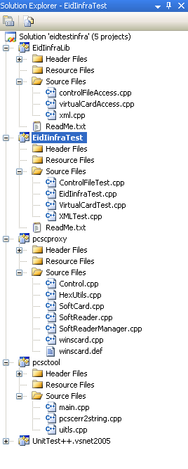

Note that EidInfraLib project produces a .lib library file. This library file is then used by EidInfraTest project for unit testing. EidInfraTest project in it’s turn references UnitTest++.vsnet2005 library.

The same library file generated by EidinfraLib project will also be used by the main project’s application(s). This way you are sure that the main project only uses tested modules.

Configuring projects for test environment

Make the following changes in the respective projects properties.

EidinfraLib project

Properties/Configuration Properties/General/Output directory/
..\_Binaries\$(ConfigurationName)
Properties/Configuration Properties/General/Configurqtion Type/
Static Library (.lib)

EidInfraTest project
Properties/Configuration Properties/General/Output directory/
..\_Binaries\$(ConfigurationName)
C/C++/General/Additional Include Directories/
../../ThirdParty/unittest-cpp-1.3/UnitTest ++/src;..\..\include
Properties/Configuration Properties/Build Events/Post-Build Event/
..\_Binaries\$(ConfigurationName)\$(ProjectName).exe

